Step 1: Created SSH Key

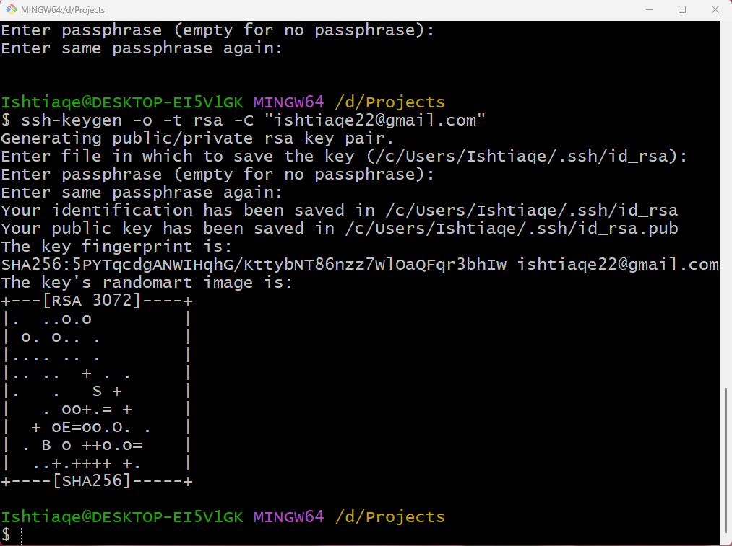

Step 2: Cloned Repo using SSH

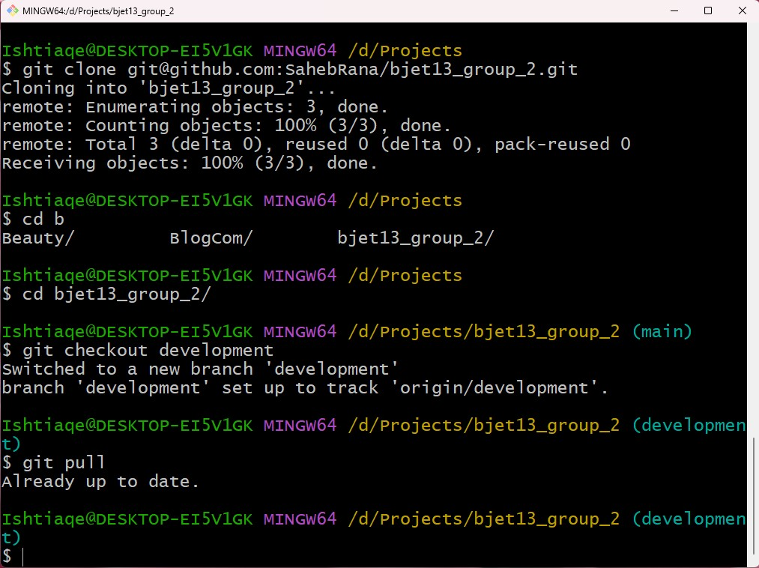

Step 3: Created Task 3 Branch

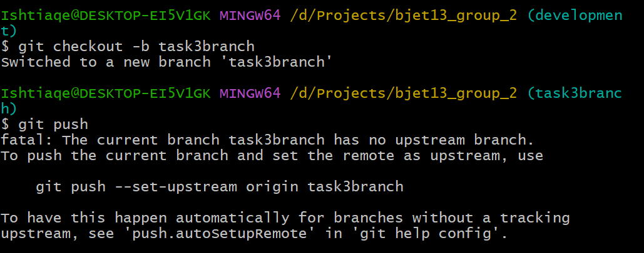

Step 4: Added changes, pulled branch, attempted merge.

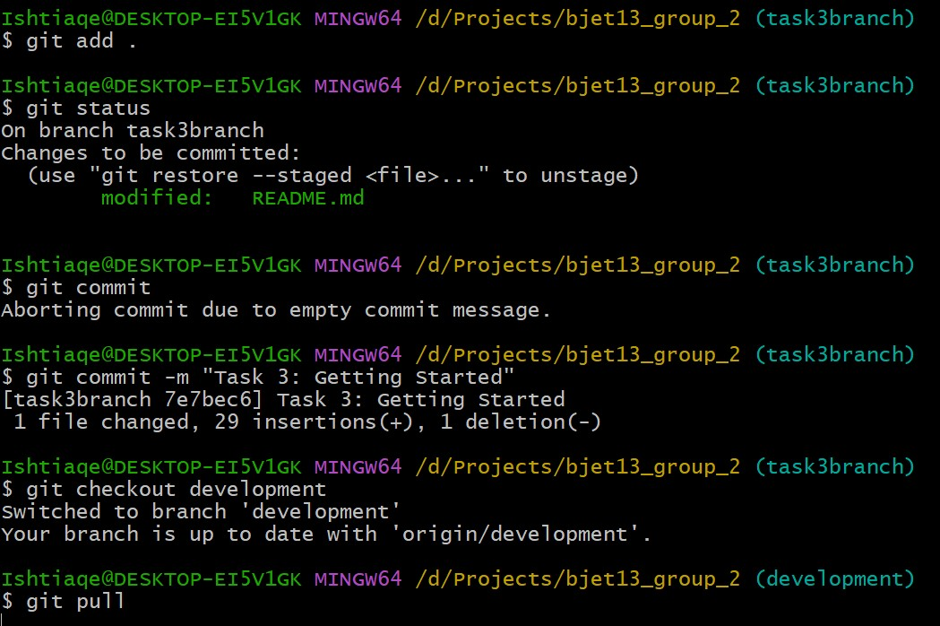

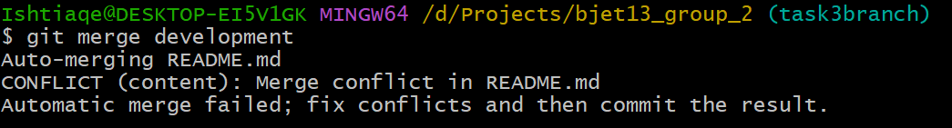

Step 5: Resolved Conflict and pushed merge.

